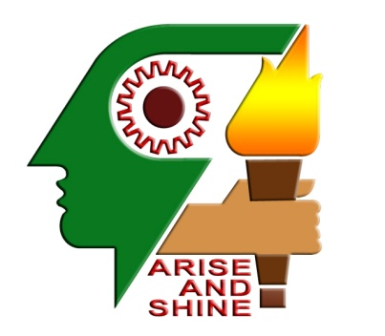



KARUNYA NAGAR , COIMBATORE – 641114

DEPARTMENT OF ELECTRONICS & COMMUNICATION ENGINEERING

**HIGH SPEED MULTIPLE VIDEO CONFERENCING AND VIDEO STREAMING IN MOBILE PHONES USING ORTHOGONAL FREQUENCY DIVISION MULTIPLEXING METHOD**

**RAAJKUMAR . C SANTHOSH.R.P**

**III – B.E.(E.C.E) III – B.E.(E.C.E)**

*KARUNYA UNIVERSITY KARUNYA UNIVERSITY*

**9788373609 9003536834**

raajkumar58ece@gmail.com [santhosh007ece@gmail.com](mailto:santhosh007ece@gmail.com)

**High speed Multiple Video Conferencing and Video Streaming in Mobile Phones using Orthogonal Frequency Division Multiplexing Method**

Santhosh.R.P Raajkumar.C

*Karunya University Karunya university*

[santhosh007ece@gmail.com](mailto:santhosh007ece@gmail.com) [raajkumar58ece@gmail.com](mailto:raajkumar58ece@gmail.com)

**Abstract**

*This paper gives a brief idea of how the Orthogonal Frequency Division Multiplexing (OFDM) method is used in fourth generation mobile communication. Different generations have been developing since then each generation coming out overcoming previous generation drawbacks. One such technology in fourth generation is OFDM. OFDM based technique looks more promising as a 4G standard surpassing the 3G standards .So, a complete review of OFDM is provided explaining its spectrum utilization, transmitter, receiver, its mathematical description, Fast Fourier Transforms, frequency to time domain conversion . We explained how signals are multiplexed using OFDM and transmitted using MIMO technology, advantages of OFDM and applications. We also discussed how multiple video conferencing can be done in mobile phones using this technique. Finally, the various fields where the OFDM technique will dominate in service sector.*